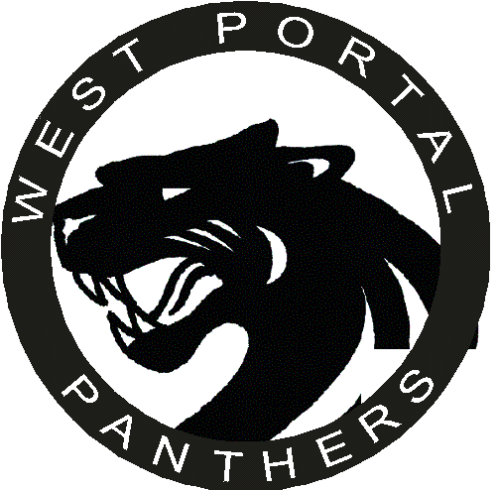

West Portal School Site Council Meeting

Agenda
March 1, 2007, 4:30
- Approval of 1-30-07 minutes (Handout)
- Review of Community Input from 1st Community Meeting
- Review and discussion of 07/08 Academic Plan Draft
- Planning for 2nd Community Meeting
- Review of 07/08 Budget
- Other Business
  - PIP program
  - Construction update
- Next meeting – April 12, 2007
Timeline for Academic Plan and Community Meetings
    - 2nd Community Meeting by Wednesday, March 7, 2007
    - Preliminary Academic Plan due on March 16th
    - Academic Plan Review – Monday, March 26th 3:30pm

